Ideation Phase

**Define the Problem Statements**

|  |  |
| --- | --- |
| Date | 01 October 2022 |
| Team ID | PNT2022TMID40581 |
| Project Name | Classification of Arrhythmia by Using Deep Learning with 2-D ECG Spectral Image Representation |

**Customer Problem Statement Template:**

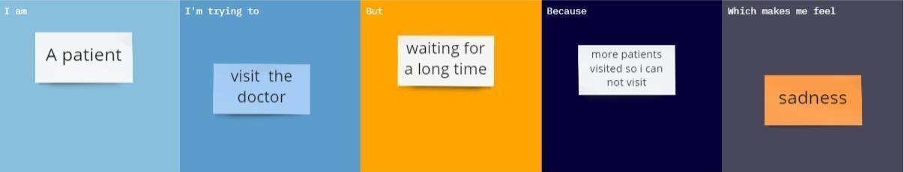Classification of Arrhythmia by Using Deep Learning with 2-D ECG Spectral Image Representation

\\

|  |  |  |  |  |  |
| --- | --- | --- | --- | --- | --- |
| **Problem Statement (PS)** | **I am**  **(Customer)** | **I’m trying to** | **But** | **Because** | **Which**  **makes me feel** |
| **PS-1** | A former | Take care of my gardens | My heart is hurting | I working too much | frustrated |
| **PS-2** | person | Healthy and won’t have heart diseases | Sometimes pain in heart | I think I have heart disease | scared |
| **PS-3** | Parent | Take care about my child | I too weakness | Sometimes my heart beat is too faster continuously | anxious |
| **PS-4** | a football player | Shoot goals | I don’t Have strength | My aim is distracted some times | sadly |